Name : Mubeen Palh

Roll No: 21K-3292

Name: Abdul Aziz

Roll No: 21K-4557

**Task 1 (Becoming a certificate Authority):**

Creating sub directories and writing single line integer to serial file:

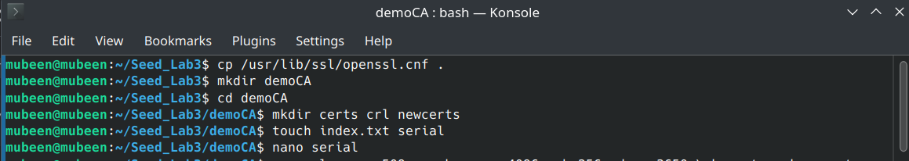



Entering the necessary information:

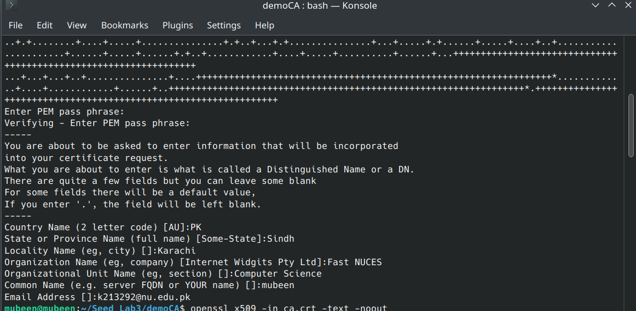  
 **Certificate:  
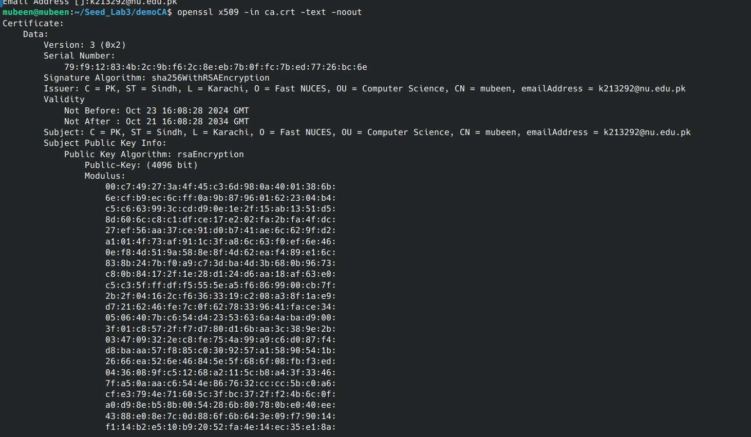**

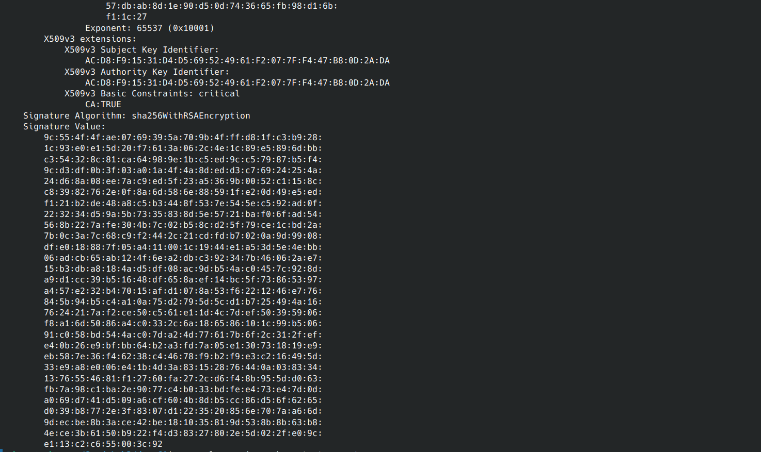

**What part of the certificate indicates this is a CA’s certificate?**

**Ans :** This field (Basic Constraints) defines whether the certificate is a CA certificate or an end-entity certificate. The value CA:TRUE explicitly states that this certificate can be used to sign other certificates, making it a CA certificate.



**What part of the certificate indicates this is a self-signed certificate?**

**Ans:** The field which specifies the issuer and the Subject indicates if it is a self-signed certificate or not. If the Issuer and subject fields are the same then it is a self-signed certificate (as shown in the picture above).



**Question: In the RSA algorithm, we have a public exponent e, a private exponent d, a modulus n, and two secret numbers p and q, such that n = pq. Please identify the values for these elements in your certificate and key files.**

**Answer:**The values are:  
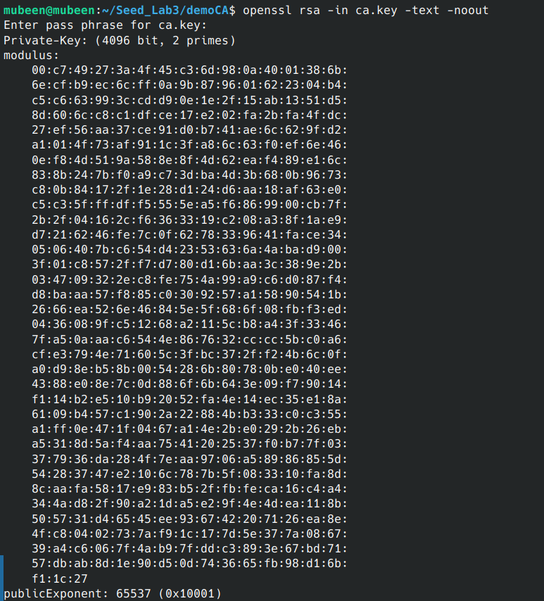

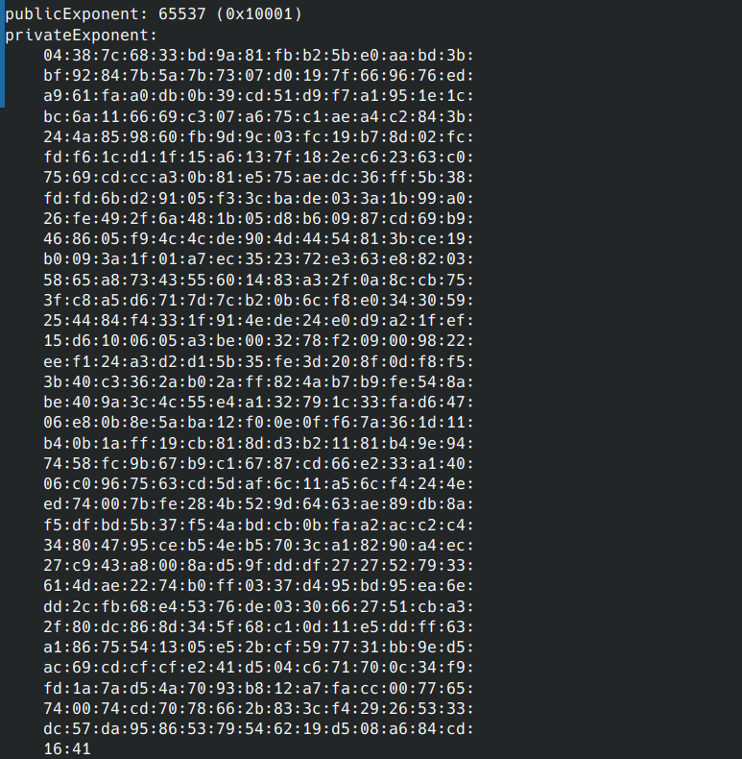

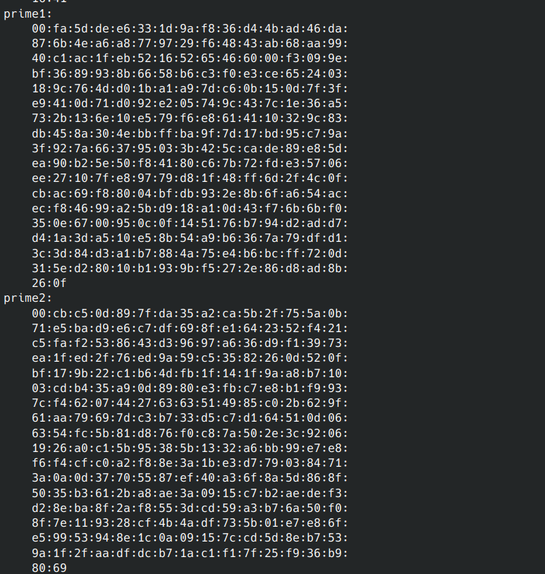

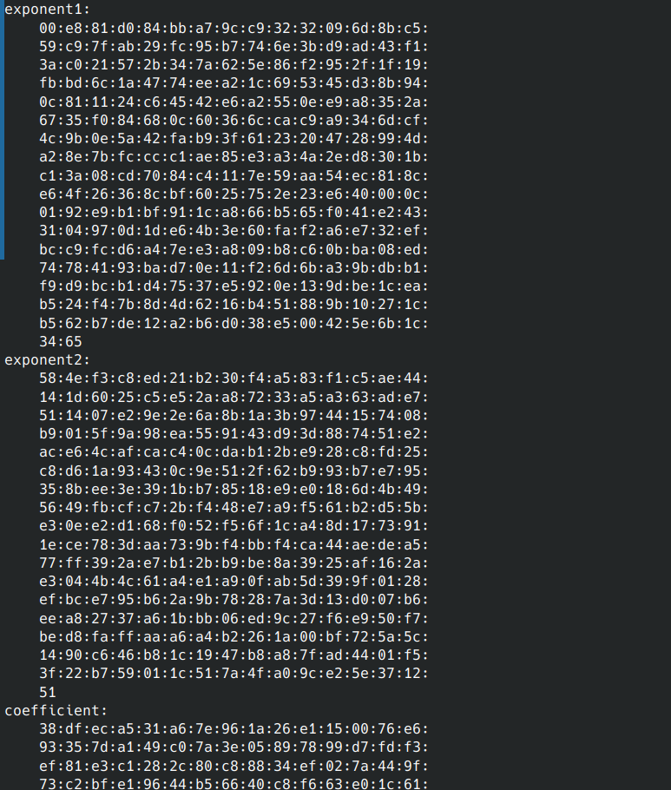

**Task 2:**

**(Setting Up the DNS Server using bind9 and docker)**

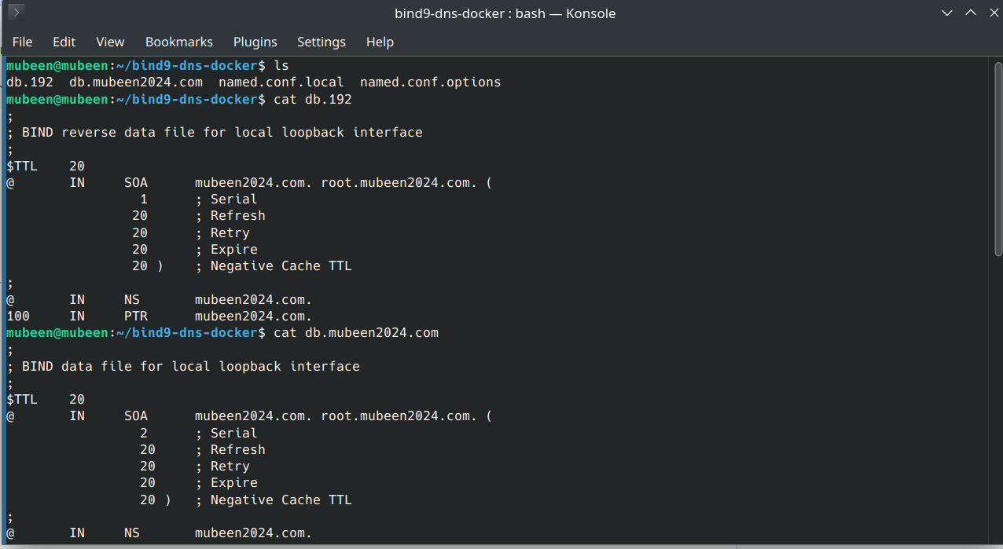

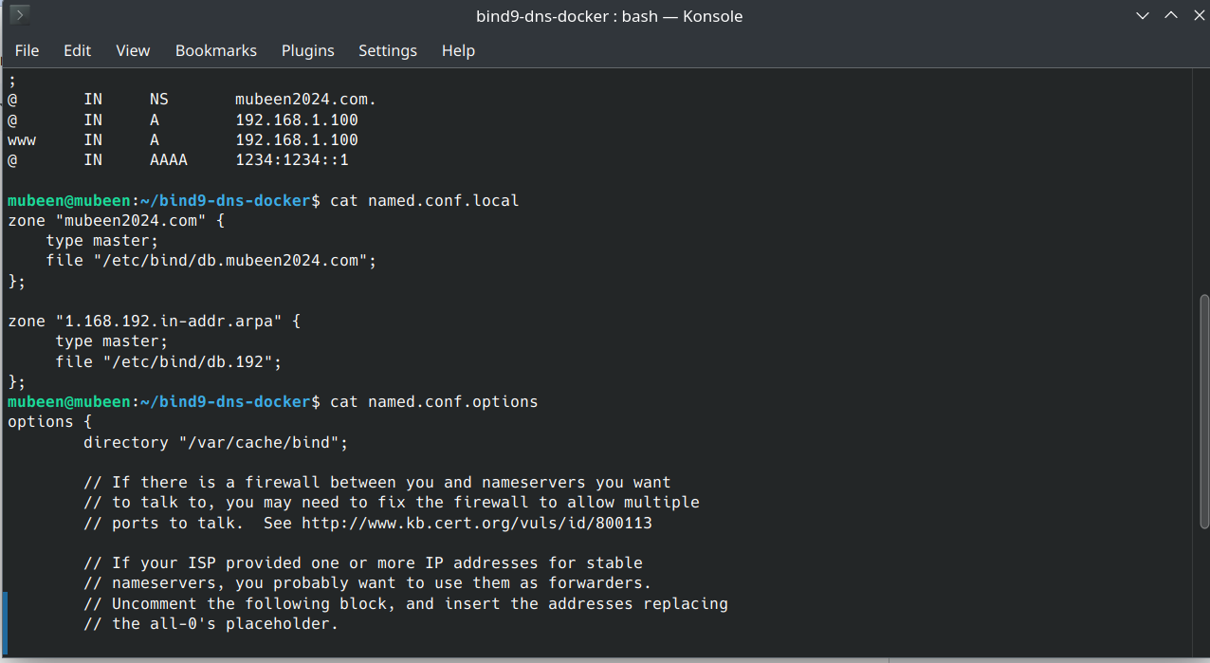

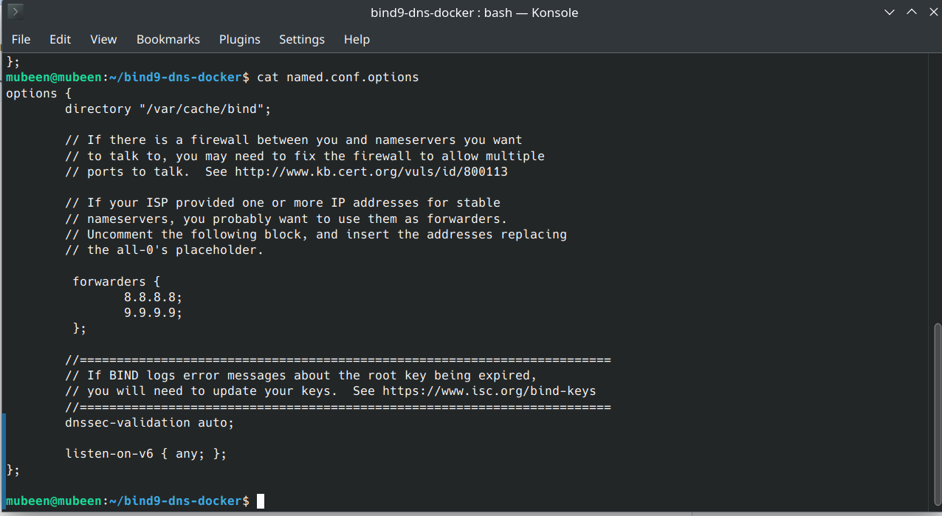

**Running docker container with bind9:  
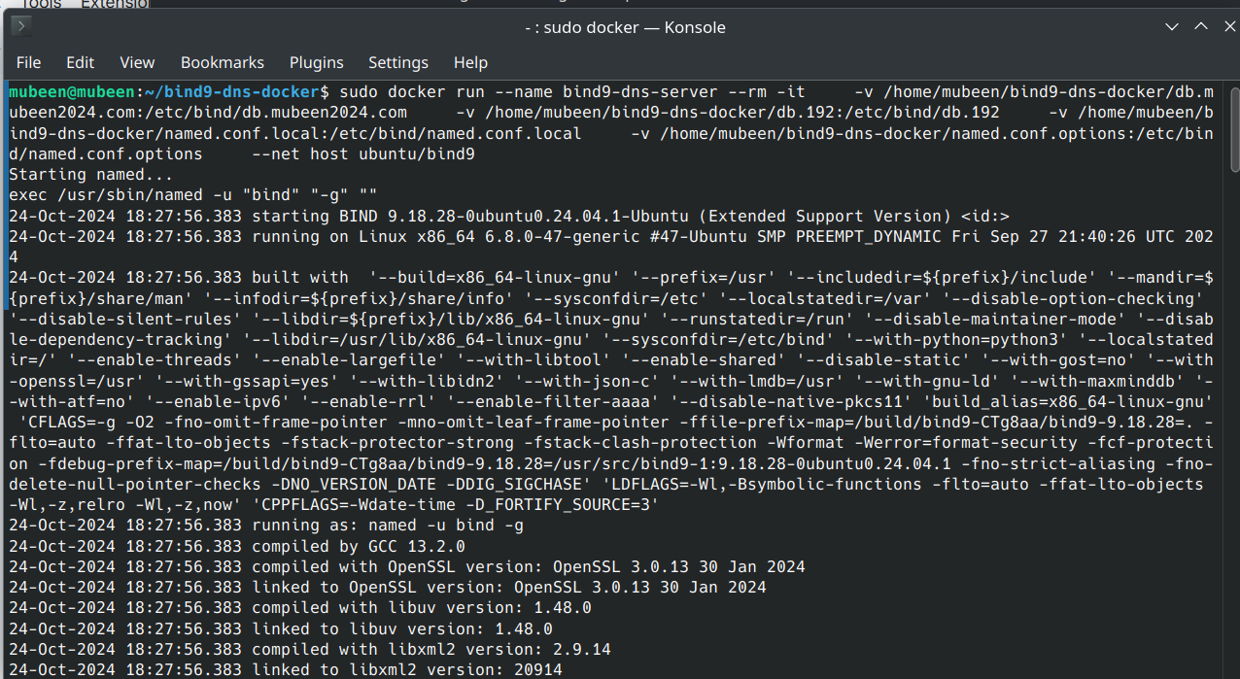**

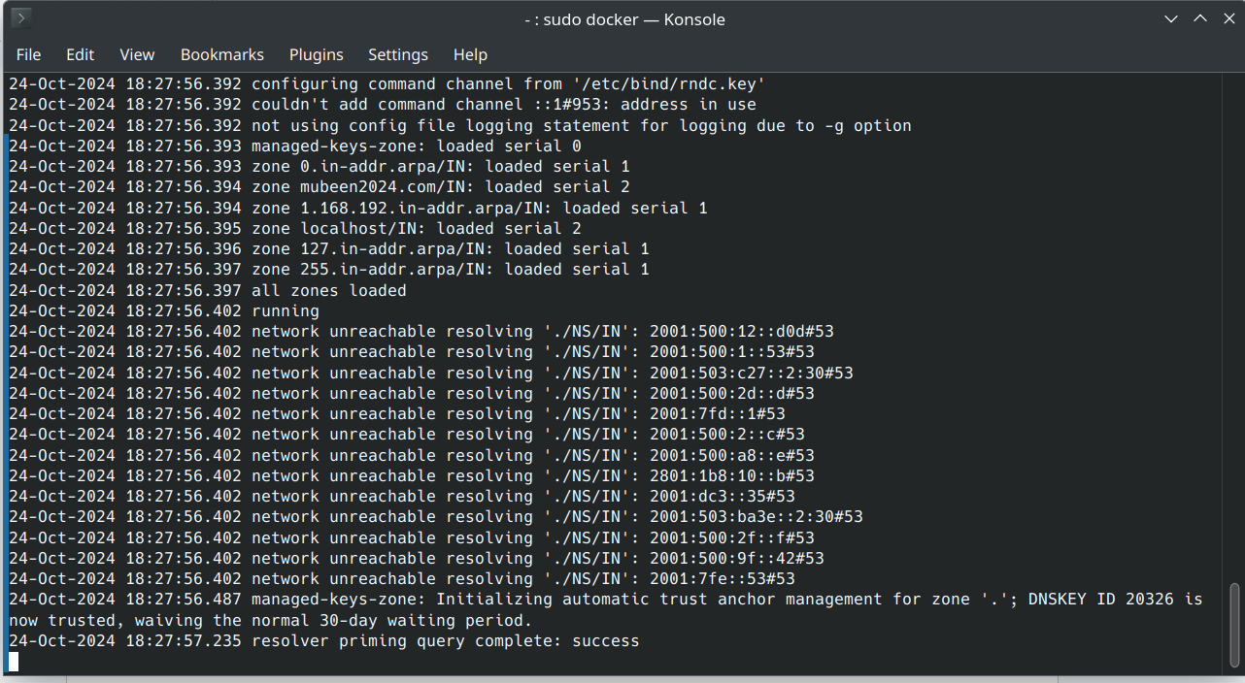

**After all configuration setup, checking the response on “**[**www.mubeen2024.com**](http://www.mubeen2024.com)**”  
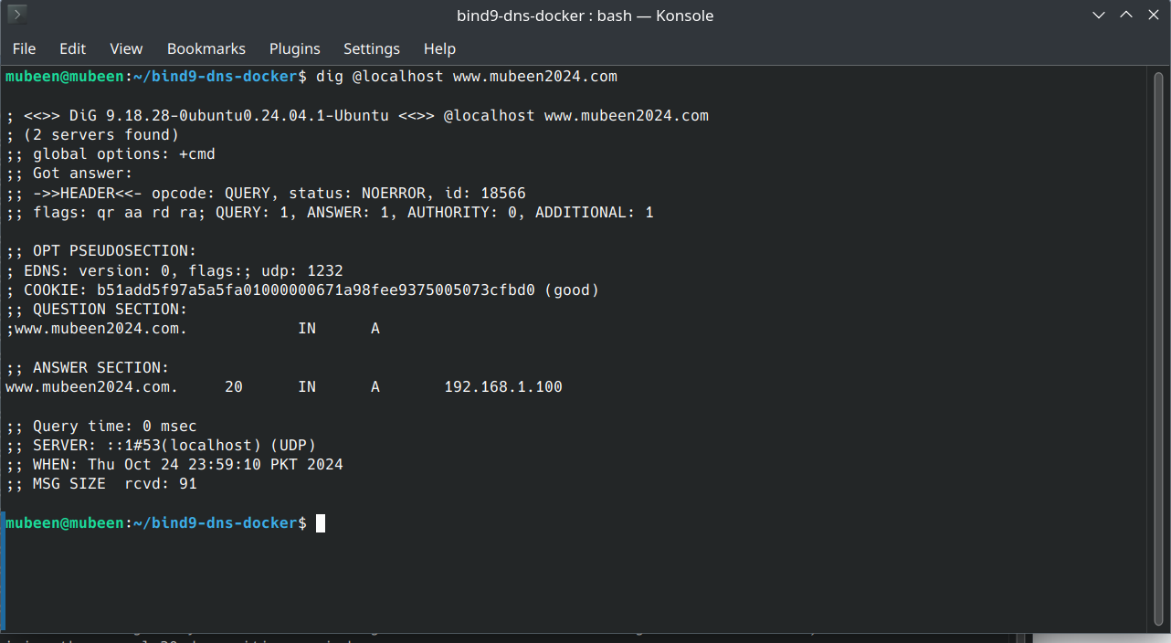**

**Running the command to generate CSR:  
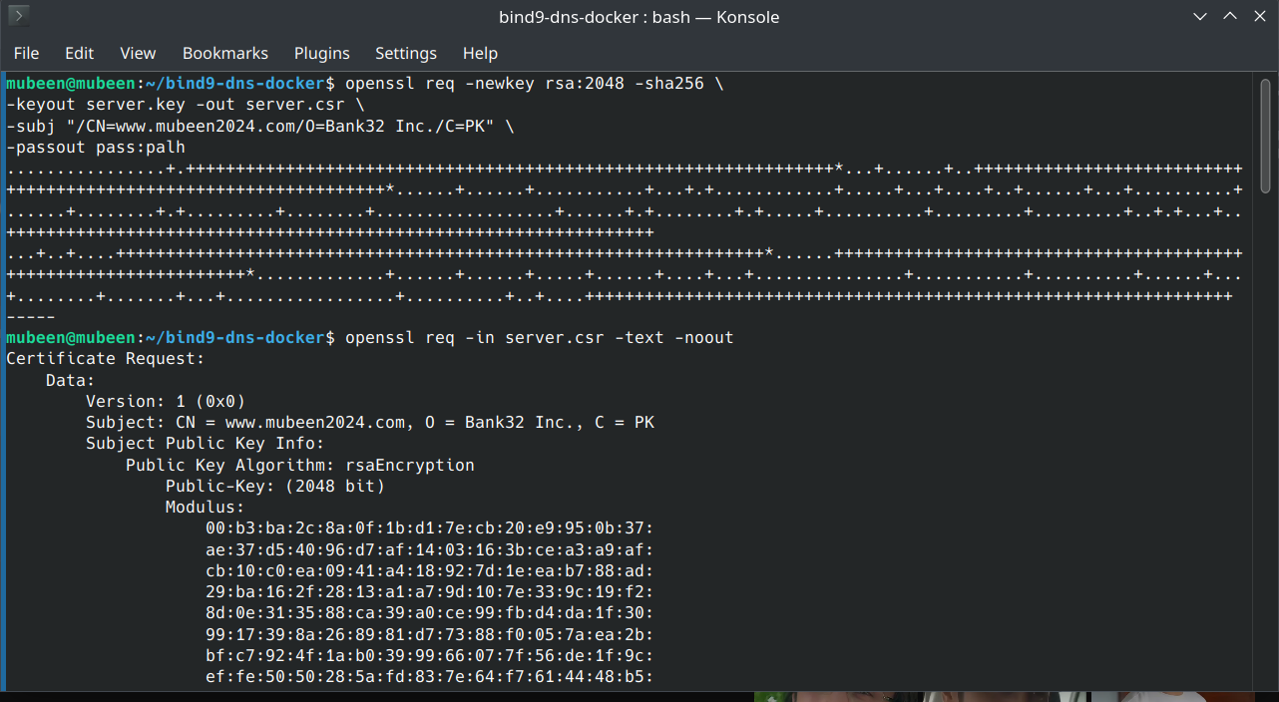**

**Viewing the contents of file:  
  
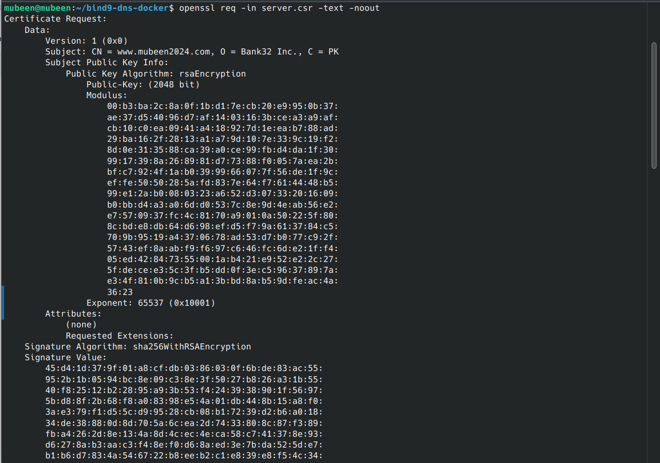**

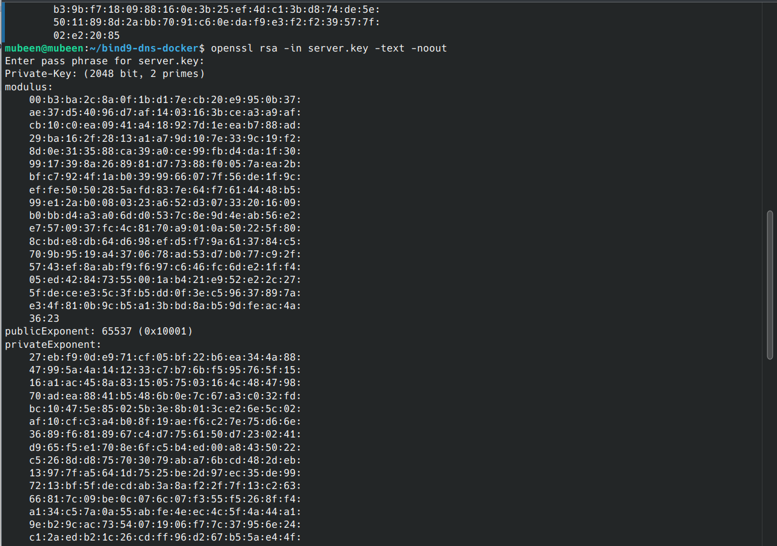

**Task:**Adding alternative names to certificate signing request:  
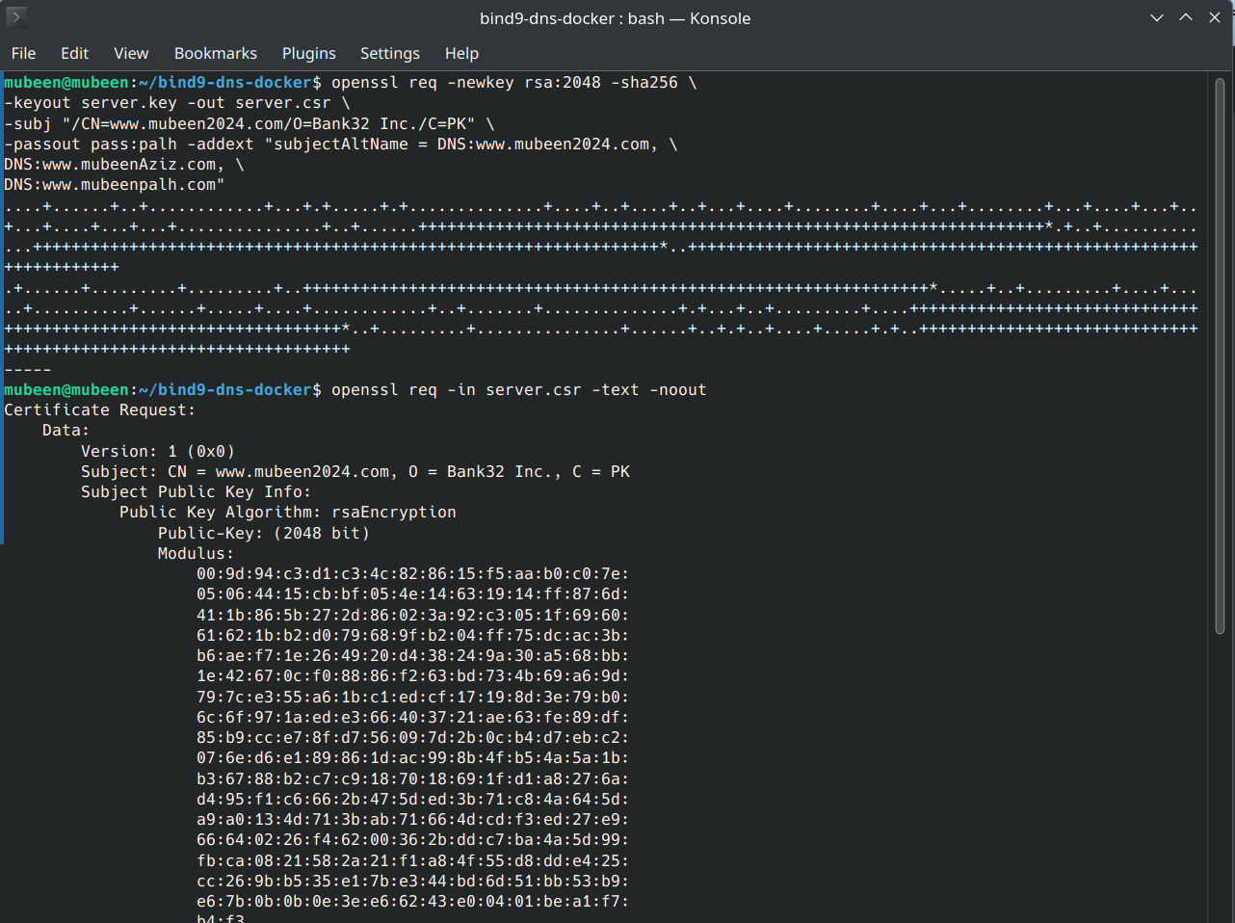



**Task 3 (Generating a Certificate for your server):**Uncommenting the field in openssl.conf file:  
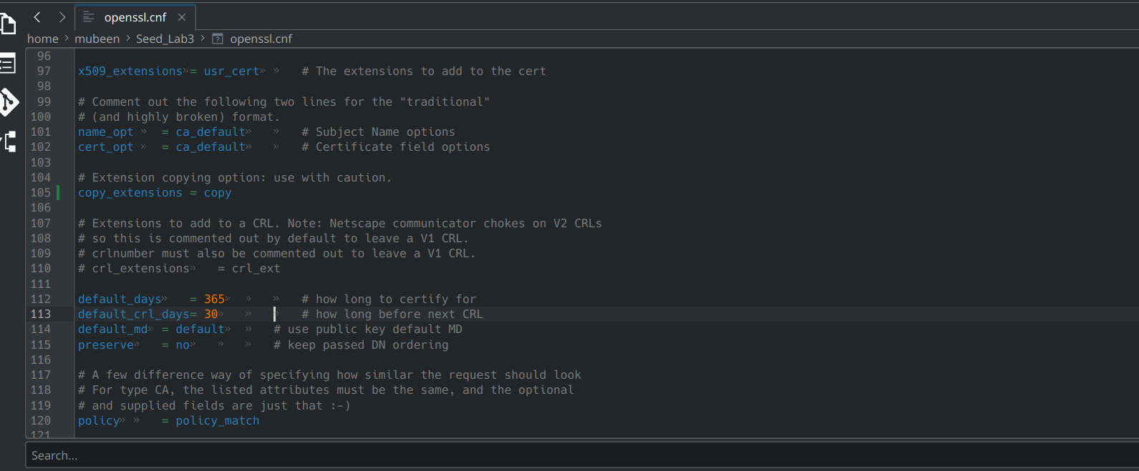

**Running the command again and checking all the subject alternatives exists or not:  
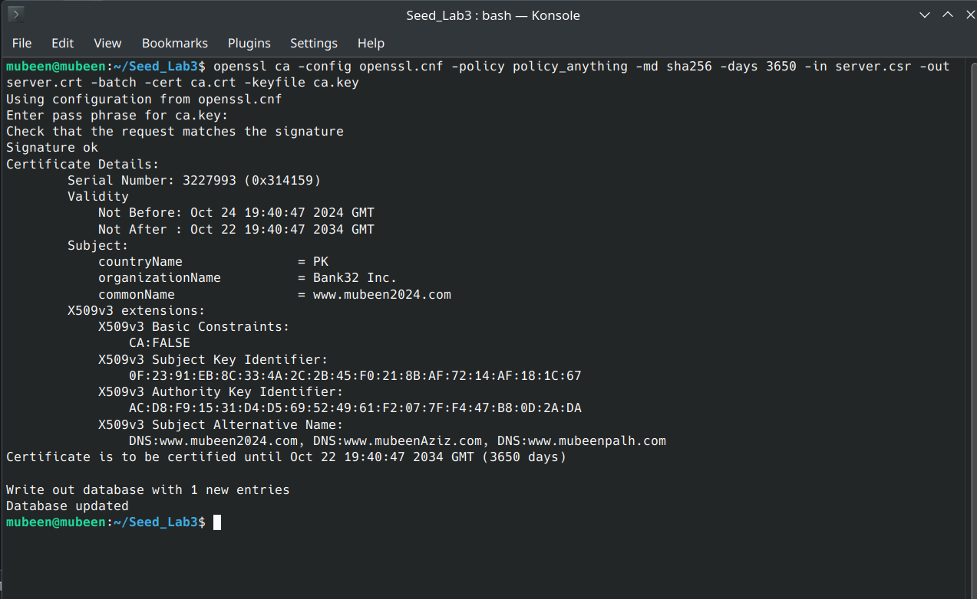**

**The subject alternatives also exist as shown in the above screen shot.**

**Task 4:  
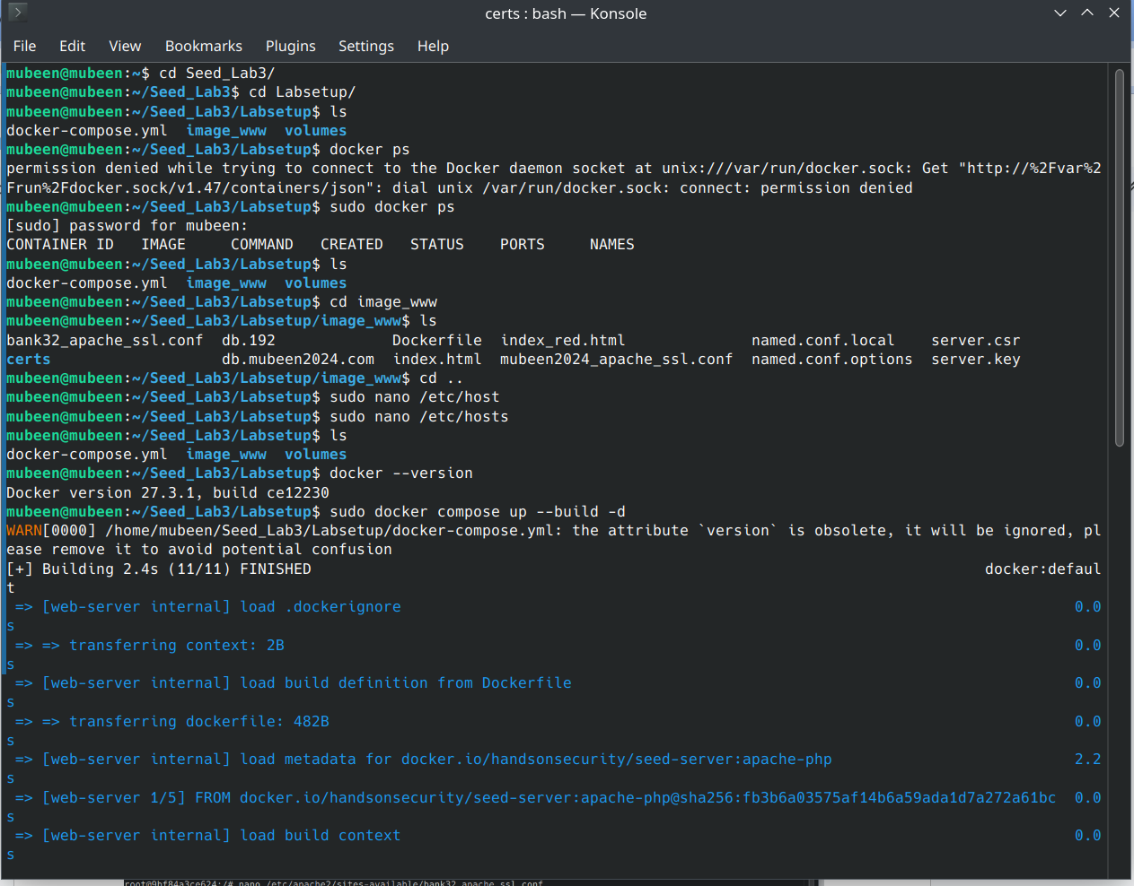**

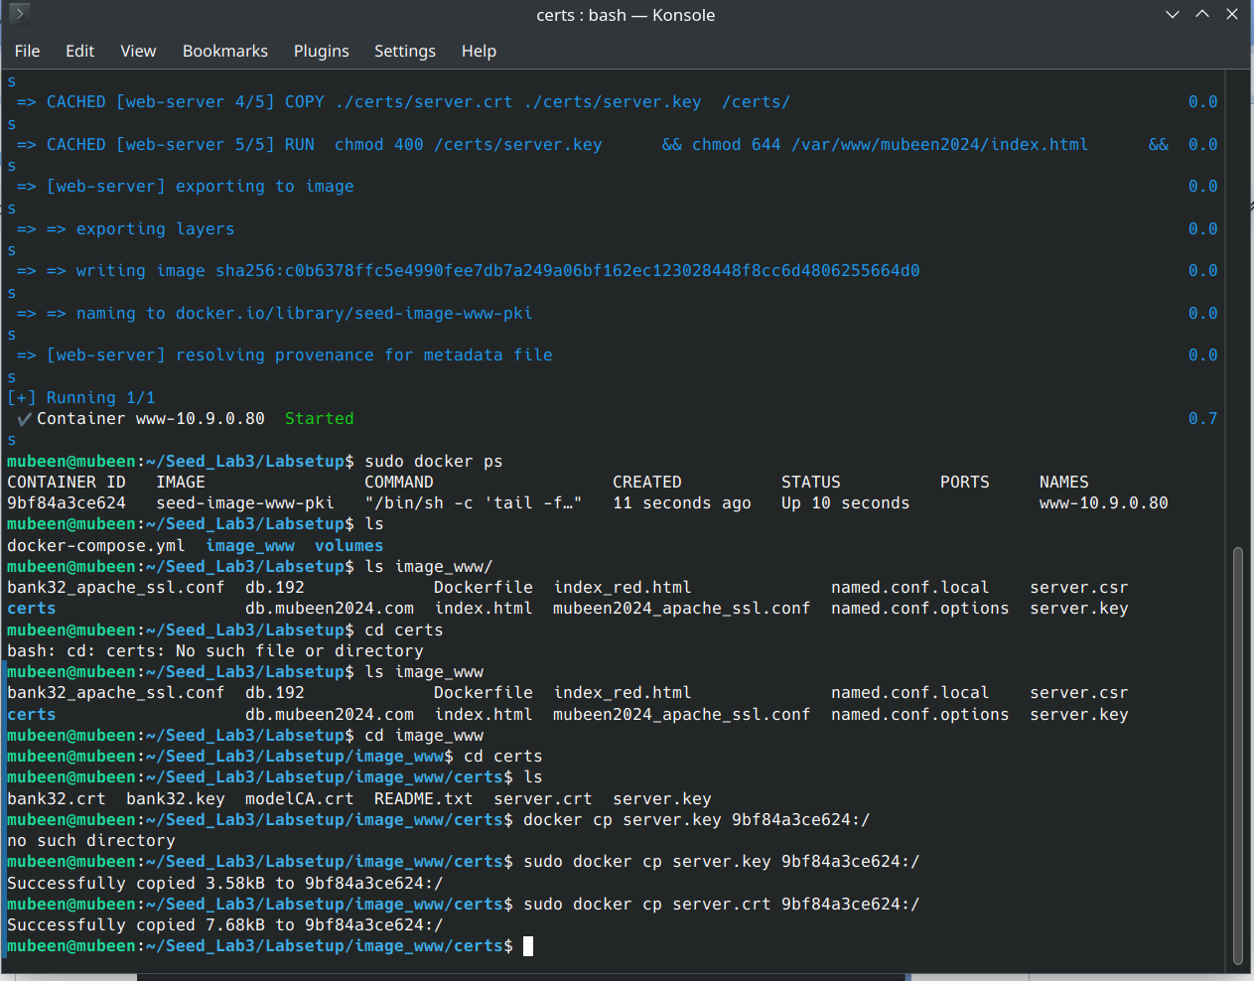

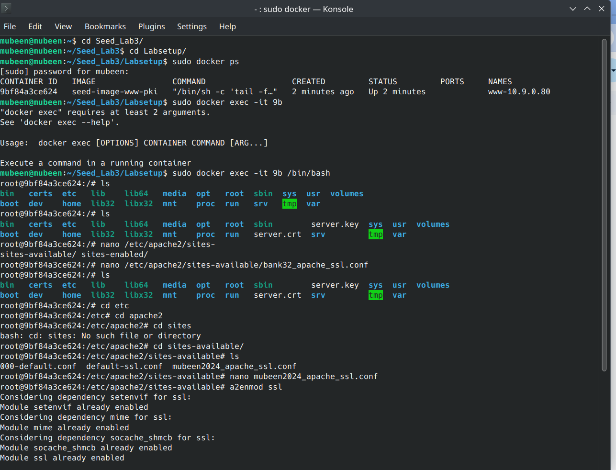

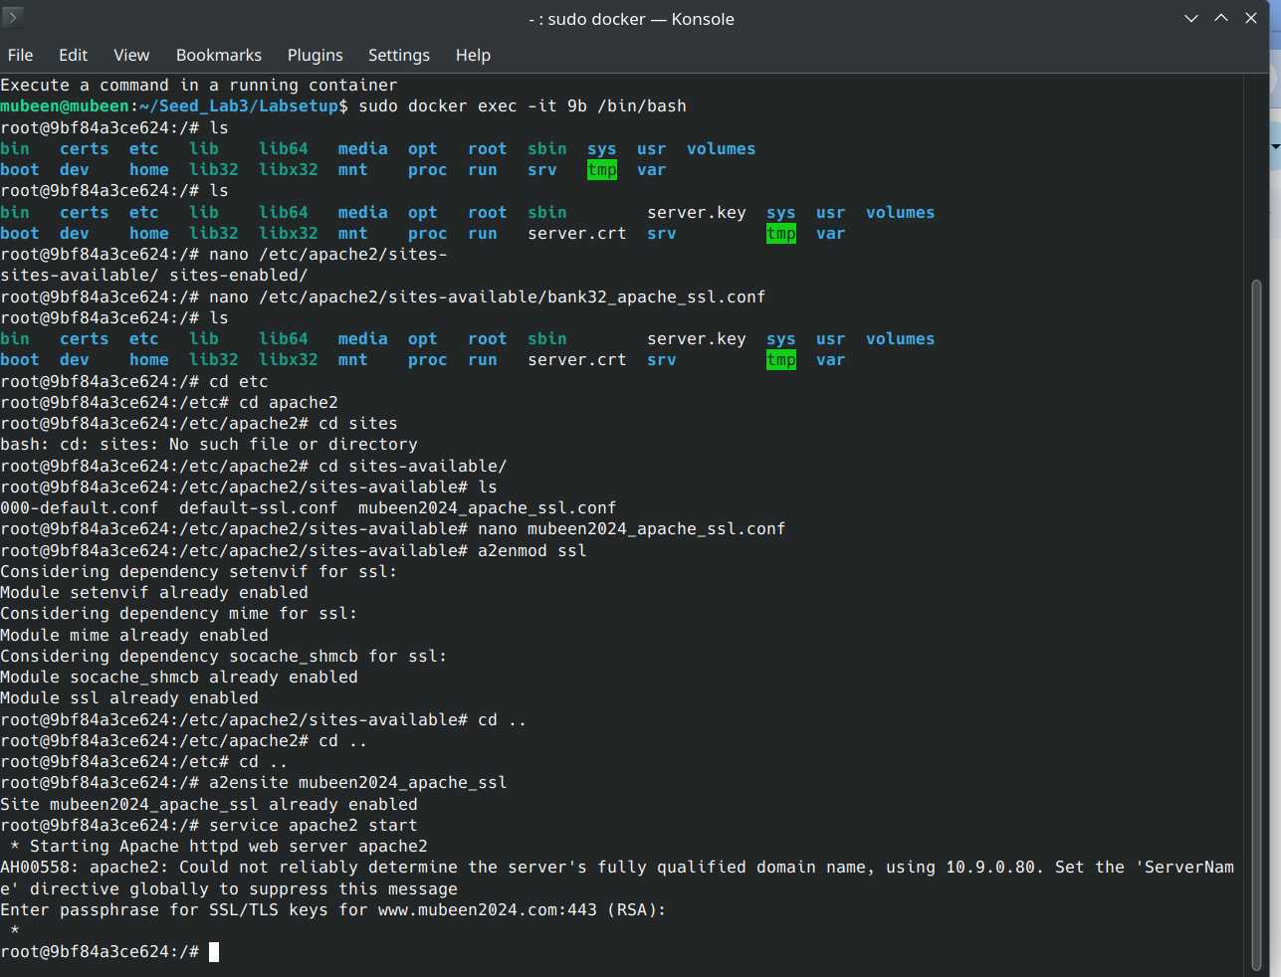

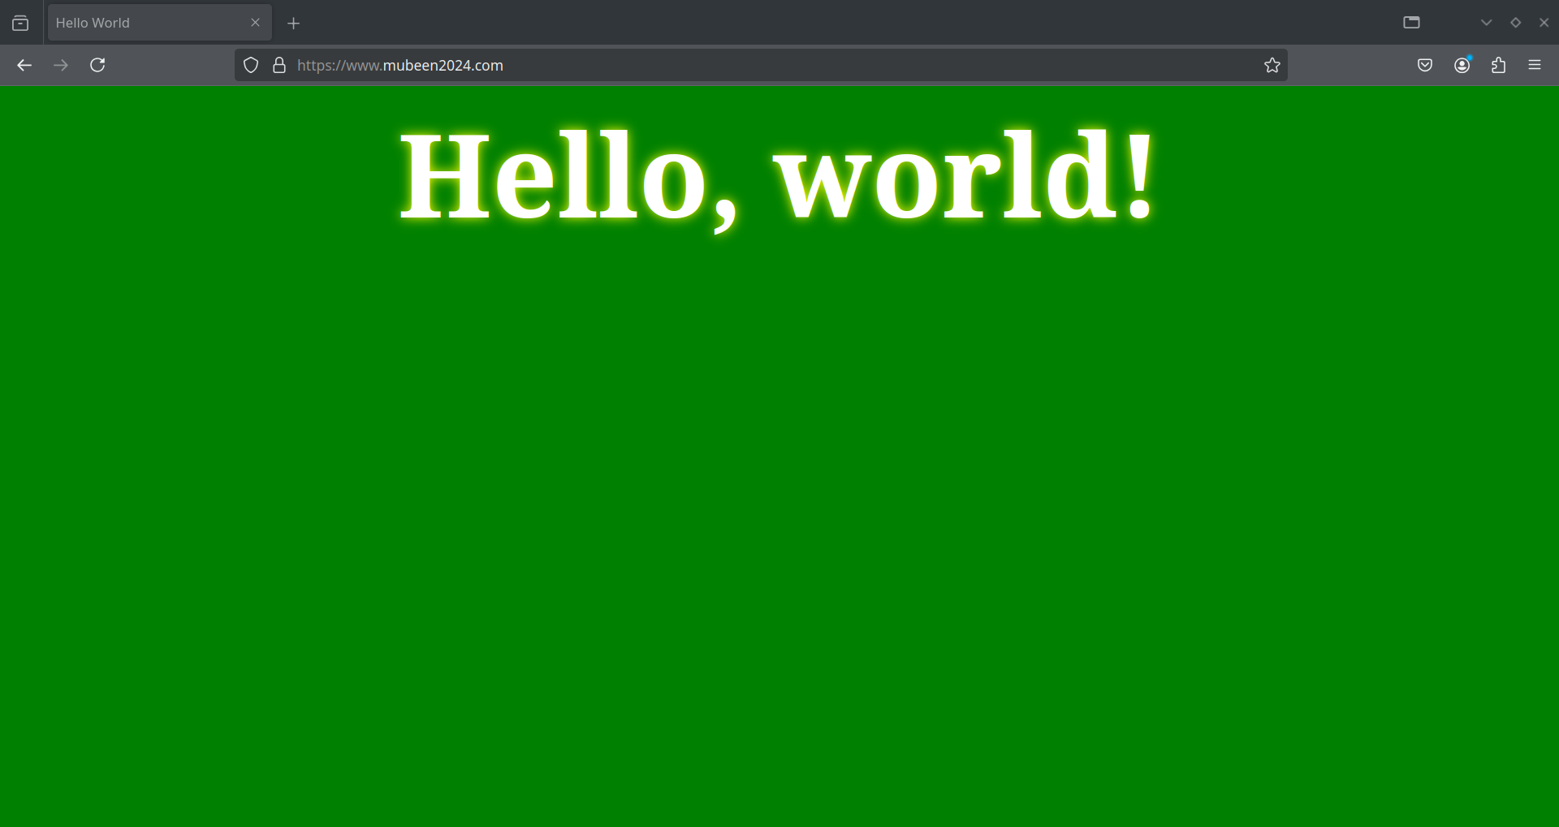

**Task 5:  
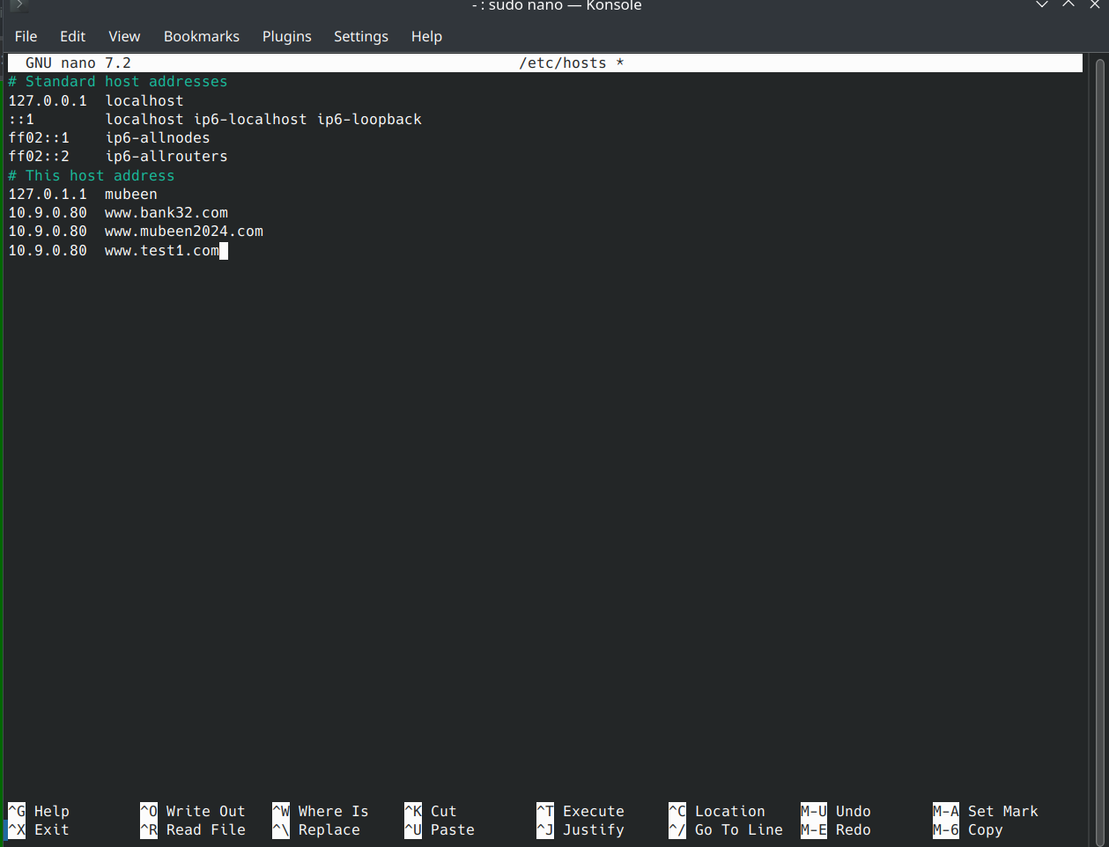**

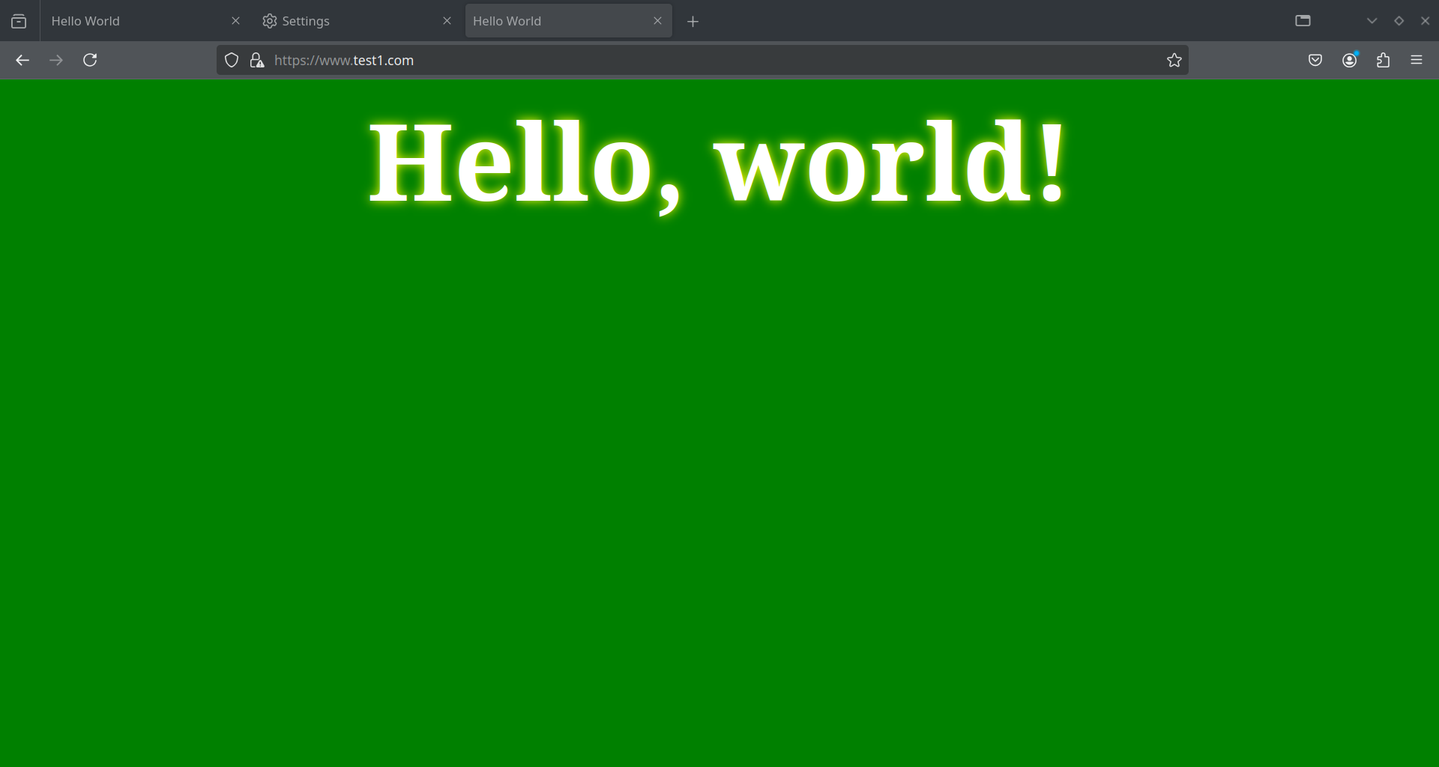

**Task 6:**

